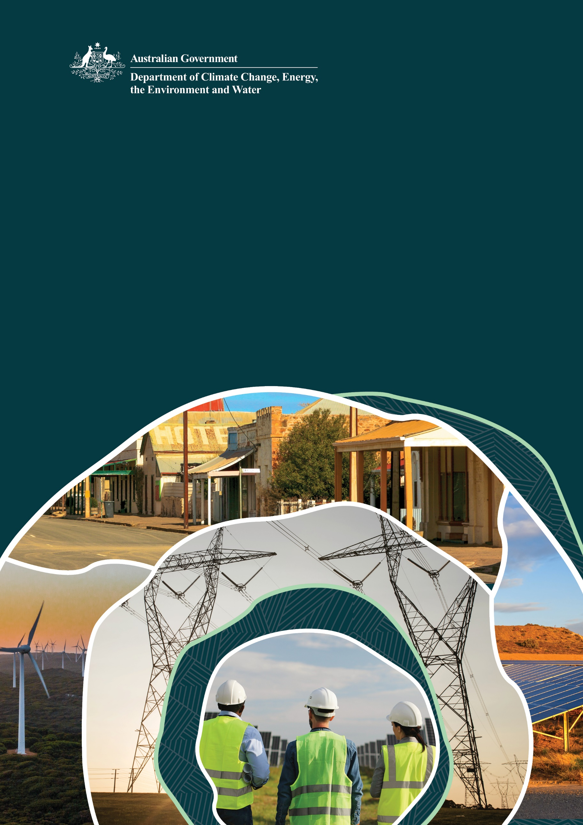
Community Engagement Review

Discussion Paper

Review by the Australian Energy Infrastructure Commissioner

Contents
Context 3
The issues 4
The review 6
Terms of Reference 7

Context
The Australian Government has committed to reducing its greenhouse gas emissions to 43% below 2005 levels by the year 2030. Further, each Australian state has set 2030 emissions reduction targets and most have a renewable energy target. Finally, the Australian Government has committed to increasing the amount of energy produced from renewable sources to 82% across the National Electricity Market by 2030.
According to the Australian Energy Market Operator’s (AEMO’s) 2022 Integrated System Plan (ISP), achieving these various commitments will involve the construction and deployment of approximately nine times the current large-scale renewable energy generation production capacity (principally solar and wind farms), nearly five times smaller scale solar PV capacity (e.g. roof-top solar), and three times the firming capacity from sources including batteries and hydro generation.
The electrification of our transport, industry, offices and homes will almost double the demand for electricity each year to replace gas, petrol and other fuels. The most likely scenario considered in the AEMO’s ISP will require the construction of at least 10,000 km of new transmission lines by 2050.
Australia has been shifting to renewable energy sources for over two decades. The Renewable Energy Target has been in operation since 2001, with the initial aim to source two per cent of the nation's electricity generation from renewable sources. Various other Commonwealth, state and territory government policies and initiatives have been put in place over the years to progress the transition to renewable energy sources. The roll-out of renewables has increased rapidly in recent years. For instance, from 2017 to 2022 the electricity from renewable sources has increased from 16.9 per cent to 35.9 per cent of Australia’s total electricity generation.
The best locations for renewable energy sources are spread across the country and in different locations to traditional energy generation. Significant new and upgraded transmission lines will be needed to connect the new generation assets and transport the electricity to where it is consumed.
All levels of government are working collaboratively through the Energy and Climate Change Ministerial Council to achieve Australia’s emission reduction and renewable energy targets. This includes key actions under the National Energy Transformation Partnership. However, it is not just about meeting commitments and targets – it is also a race against time to ensure we have security of supply in place well ahead of the announced closure dates for significant coal-fired assets.

The issues
Achieving the transition to renewable energy and electrification will require complex changes, and opportunities, throughout regional Australia.
Regional communities will experience construction of infrastructure, including new solar and wind farms, pumped hydro, battery storage and high voltage transmission lines. For the first time in several decades new transmission infrastructure is being built at scale. The likelihood of such developments is increased in the new, state or territory designated Renewable Energy Zones (REZs). These REZs, selected to enable optimal renewable energy generation sites, will require new transmission infrastructure to get the electricity to where it is needed.
This new infrastructure will provide benefits for communities, including regional economic investment, job creation and community benefit fund sharing. It also creates a range of perceived and real impacts on those that provide land for the infrastructure, their neighbours and the broader community.
Examples of typical benefits and impacts can be found in the Australian Energy Infrastructure Commissioner’s 2022 Annual Report – in particular, Appendix A, Sections 1 to 3.
A material issue is the quality and effectiveness of infrastructure project proponents in their engagement and relationships with affected communities.
If engagement by a proponent is not done well and issues are not resolved in a timely fashion, the situation can quickly lead to entrenched community opposition to proposed projects. This resistance is a risk to the energy transition more broadly. Lengthy delays, less efficient outcomes or failure to complete projects are all possible outcomes associated with poor community consultation and engagement.
Communities are also seeking clarity about the overall plan for generation deployment – one that is properly integrated with the plan for transmission. While the transmission plan and deployment are absolutely essential, the targets and transition can only be achieved ultimately if the generation and storage assets are deployed in a logical and orderly fashion.
The Review will primarily focus on:
- Proponent capability for effective and successful engagement with landholders, community members and neighbours, local Councils, First Nations communities and environment groups – including identifying capability gaps that require immediate improvement;
- Landholder experience and expectations for how they have and should be engaged by proponents;
- Community and neighbour expectations for how they have and should be engaged by proponents; and
- The role of local Council in the development and deployment of the energy infrastructure, along with both their engagement expectations from proponents as well as Council’s own engagement with the community on such projects
- The leadership and vision that will bring Australians together to support and enable this massive energy transformation.

The Review will also consider:
- Appropriate and effective community engagement during the planning, environment and economic approval processes for new projects
- Perceived or actual impacts of energy infrastructure development on the environment or on agricultural land, including:
  - Emergency management, including fire and biosecurity risks
  - Increases in landholder insurance premiums
  - Tourism impacts and other aesthetic and cultural considerations
- Perceived or actual impacts of energy infrastructure development on Indigenous heritage and land rights
- Community engagement and benefit sharing including financial, local infrastructure, knowledge sharing, and any other types of benefit.

The review
The Australian Government has commissioned a review, known as the Community Engagement Review, which is being led by Andrew Dyer, the Australian Energy Infrastructure Commissioner.
The review will include a public consultation along with interviews and roundtable discussions with key stakeholders. The public consultation will seek views and submissions from community members, involved landholders, local councils and proponents – as well as other relevant stakeholders and the general public.
The Commissioner wants to hear from you on consultation practices for new renewable energy infrastructure, firming infrastructure such as pumped hydro and large-scale batteries and new transmission infrastructure. The Commissioner is interested in hearing your views about:
- What community engagement has worked well and what can we learn from it?
- How we can improve engagement that that has not worked well?
- What is needed to ensure best practice engagement is achieved in all future projects?

The review is supported by a secretariat provided by the Department of Climate Change, Energy, the Environment and Water.
The terms of reference for the review are available at Attachment A.
The webpage for public consultation can be found at:
https://consult.dcceew.gov.au/aeic-review-of-community-engagement-practices
Interviews and roundtable discussions will also be conducted in the September 2023 timeframe.
Helpful resources for background reference include:
- The Minister’s Media Release of 4 July 2023, announcing the Review
- The DCCEEW Community Engagement Review webpage
- The DCCEEW social licence web page
- A link to the Review’s Terms of Reference
- The AEIC website
- The AEIC 2022 Annual Report
- AEIC’s Opening Statement to Senate Estimates – 23 May 2023
- Queensland Renewable Energy Landholder Toolkit (QFF)
- RE-Alliance (2021) Building Trust for Transmission – Earning the Social Licence Needed to Plug in Australia’s Renewable Energy Zones
- AEIC Guideline – Considerations for Landholders before entering into Commercial Agreements
- AEMO’s 2022 Integrated System Plan

Contact the Review
If you have any questions, please send an email to cereview@dcceew.gov.au Note, submissions will not be accepted at the above email address. Submissions must be received via the consultation website.

ATTACHMENT A

Terms of Reference
Review to enhance community support and ensure that electricity transmission and renewable energy developments deliver for communities, landholders and traditional owners (the Review).
Scope of the Review
1. The Review will consider community attitudes towards renewable energy infrastructure and provide advice on the best way to maximise community engagement and benefit in planning, developing and operating renewable energy infrastructure.
2. In conducting the review, the AEIC should have regard to the following:
a. Perceived or actual environmental impacts
b. Perceived or actual impacts on agricultural land, including:
i. Emergency management, including fire and biosecurity risks;
ii. Increases in landholder insurance premiums; and
iii. Tourism impacts and other aesthetic and cultural considerations.
c. Perceived or actual impacts on Indigenous heritage and land rights
d. Community engagement and benefit sharing including financial, local infrastructure, knowledge sharing, and any other types of benefit.
3. The AEIC can advise on how to maximise community engagement within the existing regulatory and legislative frameworks, including the National Electricity Law, the National Energy Objectives and the Regulatory Investment Test for Transmission.
4. The AEIC may also provide recommendations to the existing regulatory frameworks that would better enable community engagement in all stages of planning and development.
5. The AEIC may assess current relevant government, and industry, policies and reforms, and suggest changes that improve community support for the necessary and rapid expansion of clean energy generation, while:
a. Preserving and expanding Australia’s unique flora, fauna and fragile ecosystems;
b. Supporting agriculture and other land uses, including innovative colocation approaches;
c. Respecting First Nations people and ensuring they have opportunities to benefit from the transition;
d. Delivering community benefits in consultation with communities including any financial benefits, local employment opportunities and skills development;
e. Supporting regional development; and
6. Any other related matters.
Process for the Review
The Review will be led by the Australian Energy Infrastructure Commissioner, Mr Andrew Dyer.
Secretariat support will be provided by the Department of Climate Change, Energy, the Environment and Water.
The report and government response to recommendations will be made publicly available.
Engagement and consultation to inform the review should include:
- Publication of a discussion paper seeking public submissions,
- Regional and rural roundtables including community, worker, First Nations, environmental organisations, farmer and industry participation to discuss key issues,
- Some of these roundtables should be held in Renewable Energy Zone communities.
The Review will collaborate with relevant energy market bodies, government agencies, and draw on relevant experts that are undertaking related work such as:
- Energy market bodies including the Australian Energy Market Operator (AEMO), the Australian Energy Market Commission, and the Australian Energy Regulator,
- State Government electricity and planning agencies such as NSW Energy Co and Vic Grid,
- Non-government organisations and community groups involved in, or impacted by, the renewable energy transition,
- Industry,
- Relevant experts including the CSIRO and academics.
Where appropriate, the Review should seek to leverage existing groups and consultation processes to mitigate duplication. For example, the Review should seek to leverage consultation underway to develop a First Nations Clean Energy Strategy and work being undertaken by CSIRO on enhancing community support.
The final report will be delivered to the Minister for Climate Change and Energy by the end of 2023.

AEMO (2022) 2022 Integrated System Plan for the National Electricity Market p.10 available at: https://aemo.com.au/-/media/files/major-publications/isp/2022/2022-documents/2022-integrated-system-plan-isp.pdf?la=en
Ibid p. 9
Ibid p.12.
Clean Energy Regulator History of the Scheme webpage available at: https://www.cleanenergyregulator.gov.au/RET/About-the-Renewable-Energy-Target/History-of-the-scheme
Clean Energy Council (2023) Clean Energy Australia Report 2023 p. 7 available at: https://assets.cleanenergycouncil.org.au/documents/Clean-Energy-Australia-Report-2023.pdf

